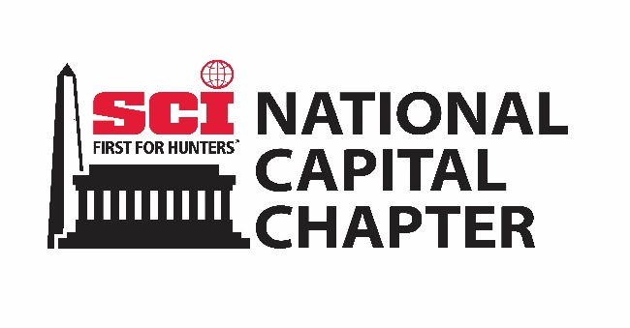
National Capital Chapter of Safari Club International
2026 BANQUET DONATION
Hunt - Live Auction
Donation Form

Please type or print legibly and return to:
David Stingl
1127 Amanda Drive, Great Falls, VA 22066
(571) 758-7456
bawanadavenccsci@gmail.com

DONATED BY:

NAME: ______________________________________________________________________________

ADDRESS: ____________________________________________________________________________

PHONE: ______________________________________________________________________________

EMAIL: ______________________________________________________________________________

WEBSITE: ____________________________________________________________________________

GAME TO BE HUNTED: __________________________________________________________________

LOCATION OF HUNT: ___________________________________________________________________

OUTFITTER/GUIDE: ____________________________________________________________________

OUTFITTER BUSINESS NAME: __________________________________ LICENSE #: ________________

NUMBER OF HUNTERS: ____________________ NUMBER OF NON-HUNTERS: ____________________

MAY ADDITIONAL HUNTERS BE ADDED? __________ AT WHAT COST? __________________________

MAY ADDITIONAL GUESTS BE ADDED? ____________ AT WHAT COST? __________________________

HOW MANY HUNTERS PER GUIDE: __________ WEAPONS ALLOWED: __________________________

DATE HUNTS MAY BE TAKEN: _________________________ TOTAL NUMBER OF DAYS: ____________

MAY THE HUNT BE TAKEN ON AN ALTERNATIVE DATE OR YEAR? ________________________________

VALUE OF THE TOTAL HUNT PACKAGE: _____________________________________________________

ARE THE FOLLOWING INCLUDED:

TRANSPORTATION: __________ DESCRIBE: ________________________________________________

ACCOMMODATIONS: __________ DESCRIBE: ______________________________________________

MEALS: __________ DESCRIBE: __________________________________________________________

LICENSES OR SPECIAL PERMITS: ____________________ ADDITIONAL COST: _____________________

TROPHY FEES/DAILY RATE INCLUDED? _____________________________________________________

HUNTING LAND: PUBLIC: _______________________ PRIVATE: _______________________________

NEAREST AIRPORT: _____________________ IS THERE A PICKUP FEE? _________ COST: __________

IS FIELD CARE AND TAXIDERMY PREP INCLUDED? ____________________________________________

ARE ADDITIONAL SPECIES AND UPGRADES AVAILABLE AND AT WHAT COST: _______________________

_____________________________________________________________________________________

ARE NEARBY EXCURSIONS AVAILABLE AND AT WHAT COST: ____________________________________

_____________________________________________________________________________________

ARE THERE ANY ADDITIONAL COSTS THE CLIENT IS RESPONSIBLE FOR ON THIS HUNT? PLEASE EXPLAIN:

_____________________________________________________________________________________

_____________________________________________________________________________________

THIS IS A 100% DONATION: _____________ 70/30%: _______________ OTHER: _________________

IS THERE A RESERVE YOU MUST HAVE? ___________ HOW MUCH? ____________________________

WILL YOU ATTEND OUR BANQUET ON MARCH 14th, 2026 in Falls Church, VA? ____________________

WOULD YOU LIKE A BOOTH AT OUR DONOR SHOW IN CONJUNCTION WITH THE BANQUET? _________

ADDITIONAL INFORMATION: _____________________________________________________________

_____________________________________________________________________________________

_____________________________________________________________________________________

____________________________________________ __________________________
Authorized Signature Date

Please provide high resolution artwork to be used in advertising your donation. Your donation will be recognized in our banquet program and on our website. Thank you for your donation and support of SCI.

