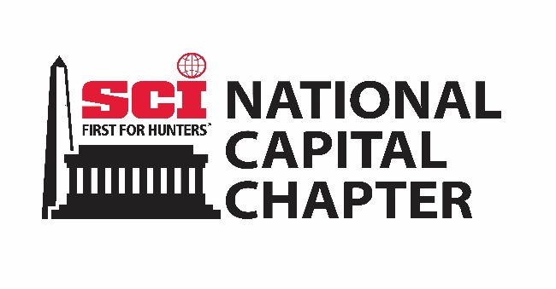
National Capital Chapter of Safari Club International
2026 BANQUET DONATION
Non-Hunt Live Auction or Silent Auction
Donation Form

Please type or print legibly and return with your generous donation to:
David Stingl
1127 Amanda Drive, Great Falls, VA 22066
(571) 758-7456
bawanadavenccsci@gmail.com

DONATED BY:

NAME: ______________________________________________________________________________

ADDRESS: ____________________________________________________________________________

PHONE: ______________________________________________________________________________

EMAIL: ______________________________________________________________________________

WEBSITE: ____________________________________________________________________________

DESCRIPTION OF DONATION/DISCOUNTED ITEM: ____________________________________________

_____________________________________________________________________________________

_____________________________________________________________________________________

_____________________________________________________________________________________

_____________________________________________________________________________________

____________________________________________ __________________________
Authorized Signature Date

Please provide high resolution artwork to be used in advertising and for recognizing your donation. Your donation will be recognized in our banquet program and on our website. Thank you for your donation and support of SCI.

